# Hello my name is Karthik R Nambiar from the June batch of Teachnook.

# I have completed my major project of making a weather forecast website by using web development.

# I used these tools for creating the website:-

* HTML
* CSS
* JavaScript
* Node.js
* Express.js
* EJS
* API from <https://openweathermap.org/>

The website looks like this

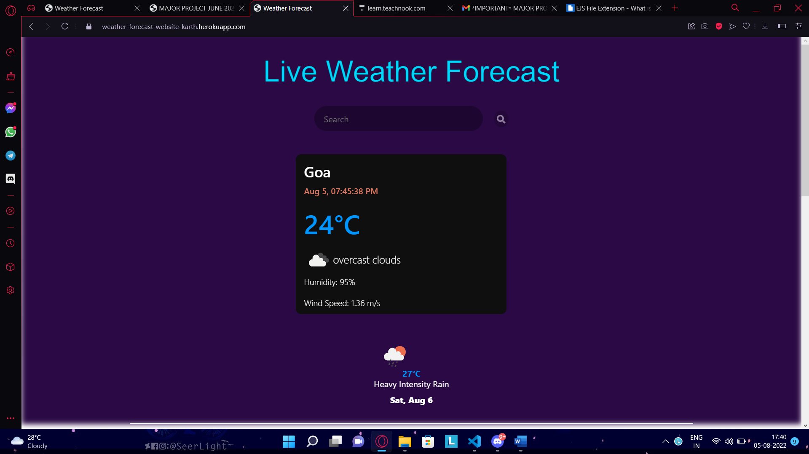

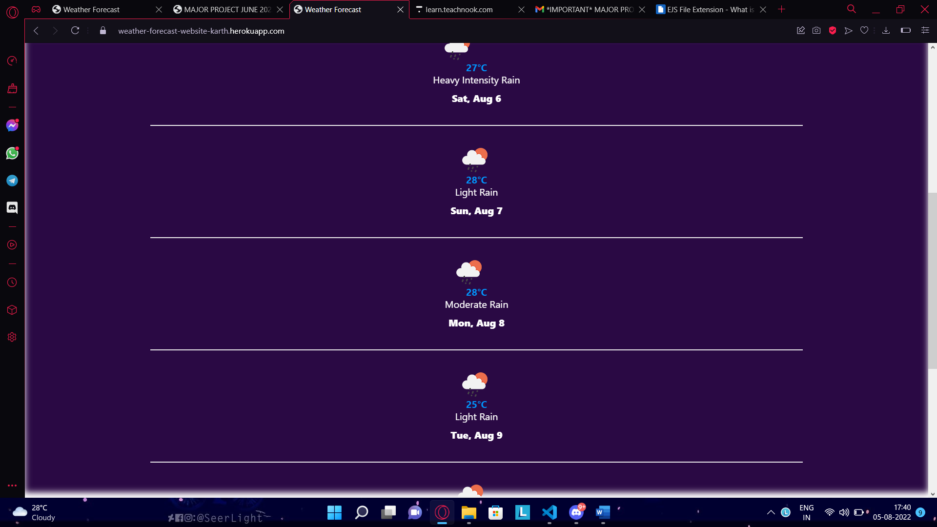

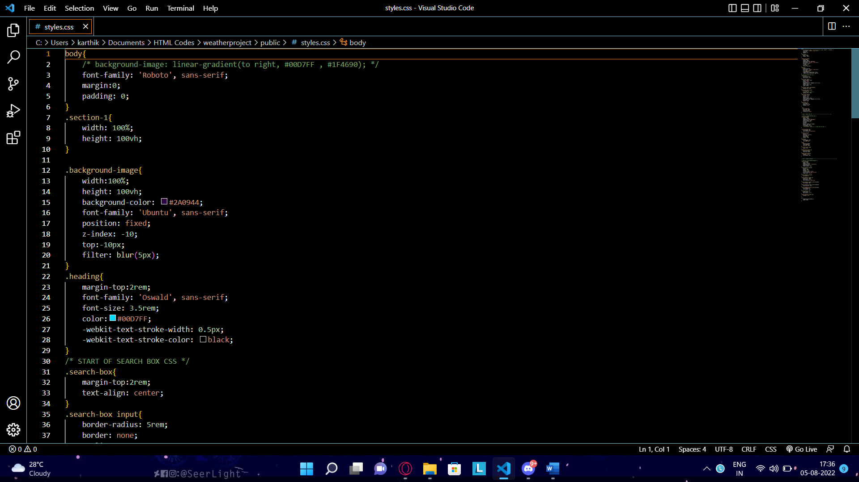

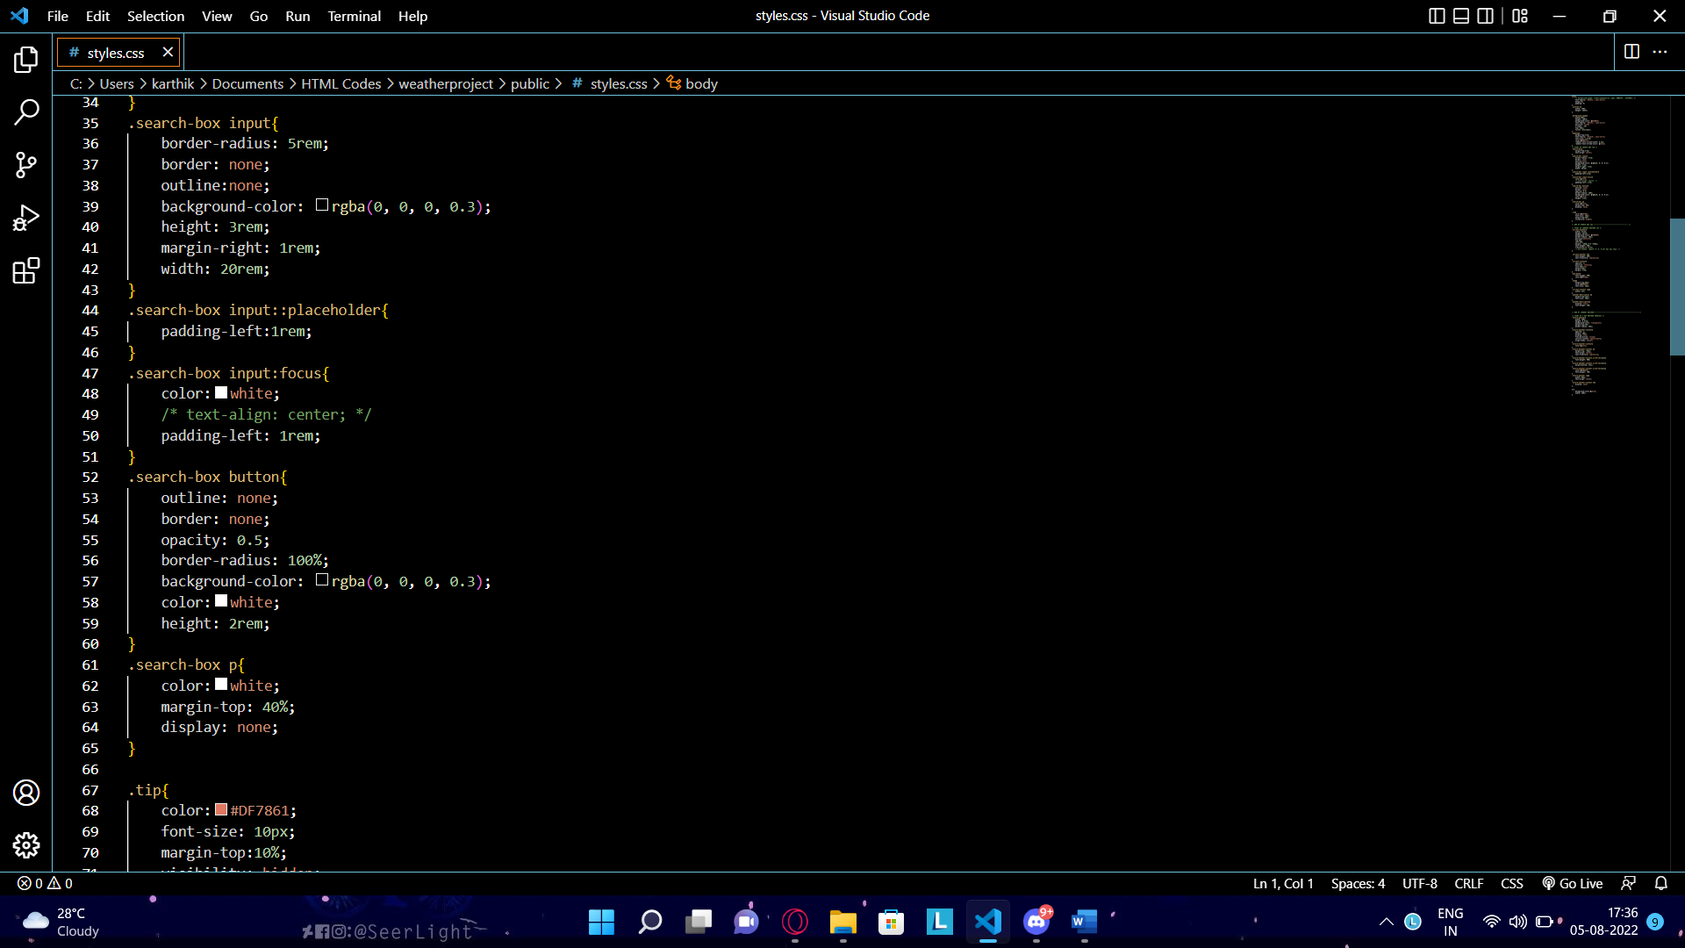

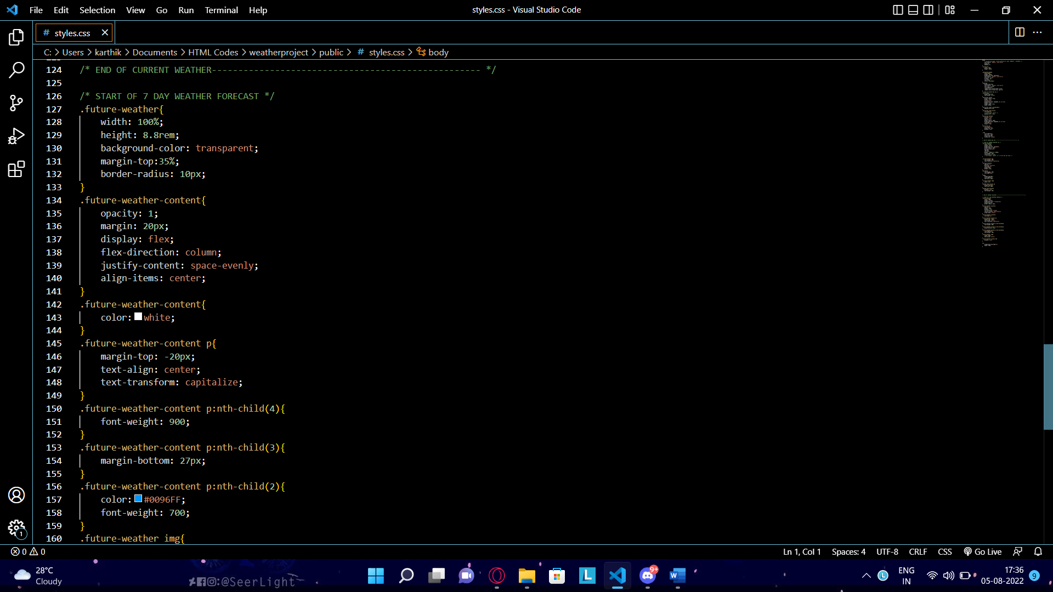

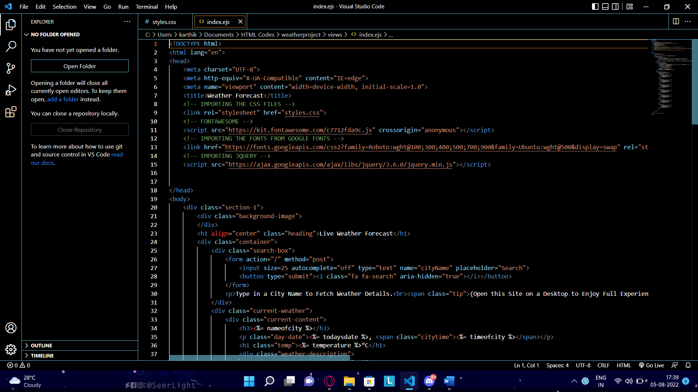

These are some examples of the coding.

The files are uploaded with the mail.

The website link is <https://weather-forecast-website-karth.herokuapp.com>